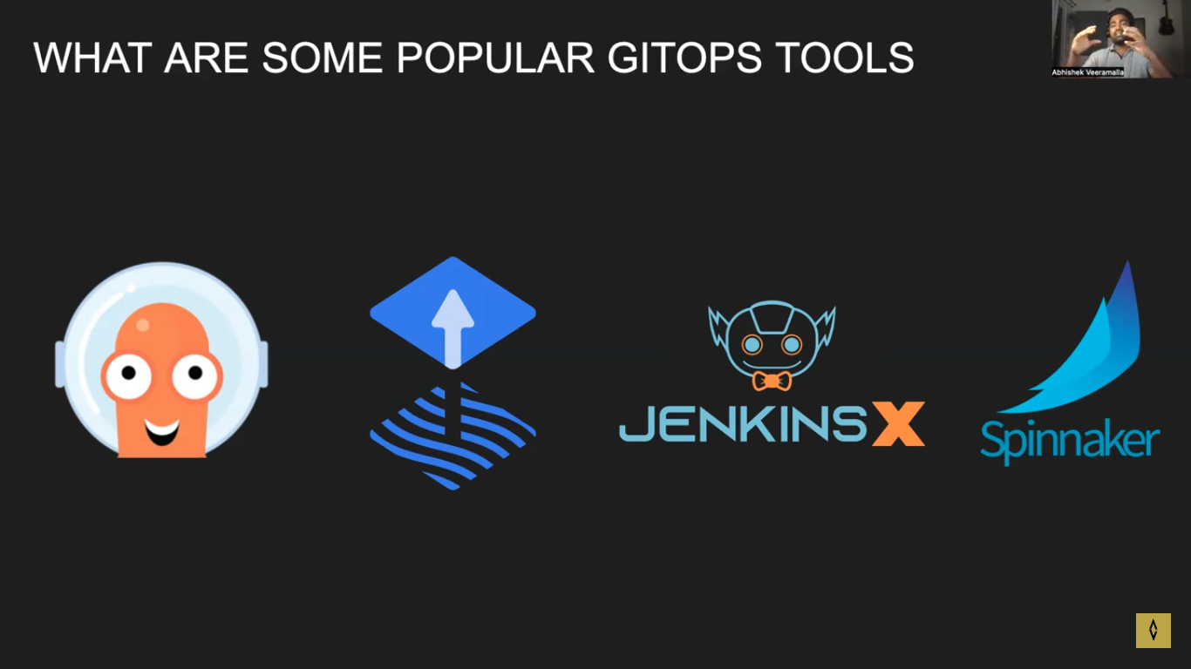

Git or any version ctrk system
Continuous monitor state /changes in both and correct canges
Argocd or any gitops tool

App ctrl will sync the state of k8s as per repo svr
1 micro get k8s state, anoter micro get state of git
Api svr is used to comm to git ops tool
Dex wiil get info from ext provider for authentication
Redis is used to cache the info as app ctrl may goes down

